**A**

**Report**

**ON**

**“ Global Malnutrition trends A Power BI Analysis 1983 to 2019’’**

**Submitted By**

**Mr. Vighnesh Jaysing Sangaonkar. (PRN:2022011041055)**

**Miss. Tanishka Uday Mane. (PRN:2022011041032)**

**Miss. Vaishnavi Namdev Jadhav. (PRN: 2022011041018)**

**Team Id:**

**PNT2025TMID02554**



***Department of Computer Science & Engineering***

***School of Engineering & Technology***

***D. Y. Patil Agriculture & Technical University, Talsande***

**Academic Year**

**2025-26**

**INDEX**

|  |  |  |
| --- | --- | --- |
| **Sr.No** | **Topic Name** | **Page No** |
| 1 | Introduction | 3 |
| 2 | Ideation Phase | 4 |
| 3 | Requirement Analysis | 5 |
| 4 | Project Design | 10 |
| 5 | Project Planning & Scheduling | 12 |
| 6 | Functional & Performance Testing | 14 |
| 7 | Results | **16** |
| 8 | Advantages & Disadvantages | **18** |
| 9 | Conclusion | **19** |
| 10 | Future Scope | **20** |
| 11 | Appendix | **21** |

**Final Report**

1. **Introduction**

**Project Overview: Global Malnutrition Trends Analysis**

Malnutrition is a critical global issue affecting millions of people, particularly children, in both developing and developed nations. This project, **Global Malnutrition Trends Analysis (1983-2019)**, aims to analyze historical data on malnutrition trends to identify key patterns, regional disparities, and contributing factors. By leveraging **data visualization and statistical analysis**, the project provides insights that can help policymakers, NGOs, and researchers develop effective strategies to combat malnutrition.

The project involves data collection, processing, visualization, and interpretation of global malnutrition data over a span of **36 years (1983-2019)**. Using advanced analytics tools, trends will be identified based on various indicators such as **undernourishment, child stunting, wasting, and obesity rates**. These insights will be presented in an interactive and structured manner to facilitate data-driven decision-making.

**Project Purpose & Objectives**

**Purpose:**

The purpose of this project is to analyze historical **malnutrition trends globally** to provide actionable insights for improving nutrition policies, resource allocation, and intervention programs. By identifying key trends, the project will support efforts to reduce malnutrition and promote sustainable health solutions.

**Objectives:**

1. **Data Collection & Processing** – Gather and clean malnutrition data from reliable sources such as WHO, UNICEF, and World Bank.
2. **Trend Analysis** – Identify historical patterns and variations in malnutrition rates across different regions and time periods.
3. **Visualization & Reporting** – Present insights using **charts, graphs, and dashboards** to facilitate understanding.
4. **Comparison & Regional Analysis** – Analyze malnutrition disparities based on geography, socioeconomic factors, and policy interventions.

**Decision Support** – Provide evidence-based recommendations for stakeholders such as governments, NGOs, and health organizations.

**2.Ideation Phase**

**2.1) Problem statement**

Malnutrition remains one of the most pressing global health challenges, affecting millions of individuals, particularly children, in both developing and developed nations. Despite numerous intervention programs and policies, malnutrition continues to contribute to high mortality rates, impaired cognitive development, and long-term economic consequences. The lack of comprehensive, data-driven insights into the historical trends of malnutrition makes it difficult for policymakers and organizations to implement effective, targeted solutions.

This project, Global Malnutrition Trends Analysis (1983-2019), aims to address this issue by analyzing historical malnutrition data to identify patterns, regional disparities, and underlying factors contributing to malnutrition. By leveraging data visualization, statistical analysis, and predictive modeling, the project will provide meaningful insights into the effectiveness of past policies and interventions. The study will also highlight critical areas that require immediate attention, helping governments, NGOs, and global health organizations make informed, data-driven decisions to combat malnutrition effectively.

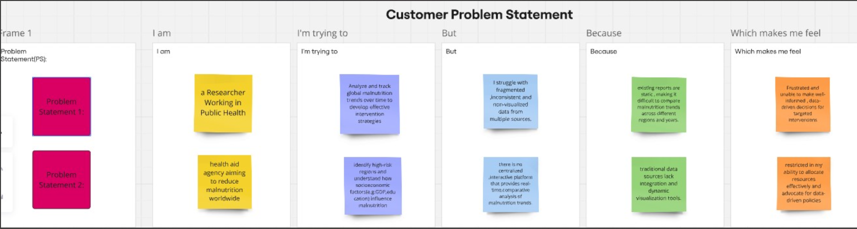

**2.2 Empathy map Canvas**

The Empathy map canvas is a visual tool used in user-centered design to gain deep insights into the needs, emotions, thoughts, and behaviors of users. It helps teams develop a clear understanding of their target audience by mapping out their experiences, challenges, and expectations.

**Says** – What the user expresses verbally (e.g., “I need nutritious food for my children.”) **Thinks** – The user’s thoughts and concerns, often not spoken aloud (e.g., “Will I be able to afford a healthy diet?”)

**Does** – The user’s actions and behaviors (e.g., Looking for food aid programs, checking nutritional labels)

**Feels** – The emotions the user experiences (e.g., Stress, frustration, or hope about finding nutritional support)

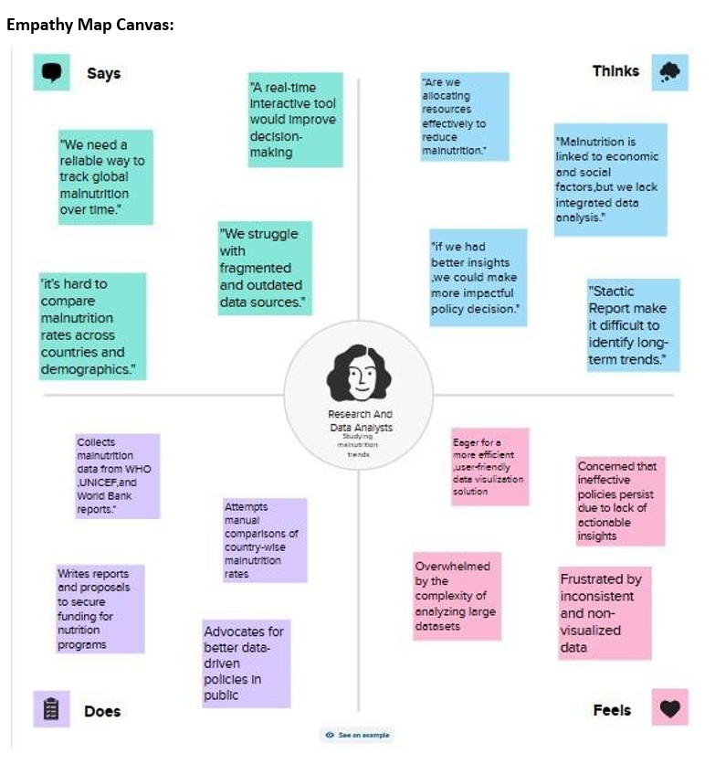

**2.3 Brainstorming**

**3.Requirment Analysis**

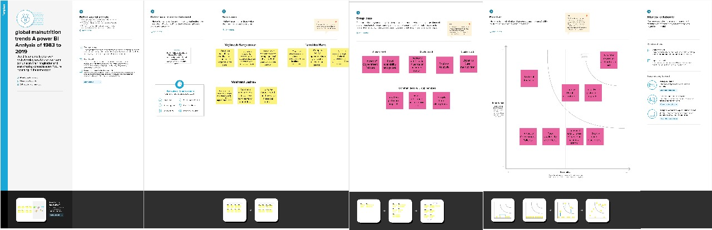

Ideation phase

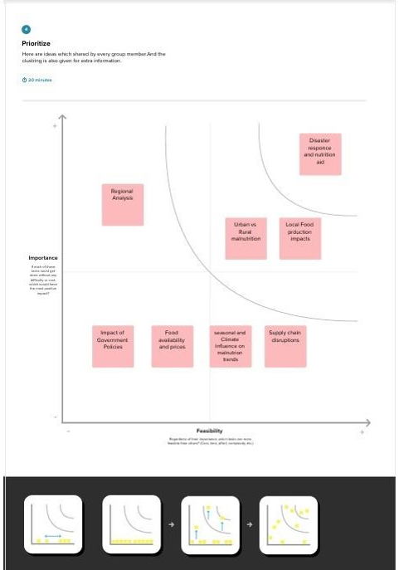

**3.1) Customer Journey map**

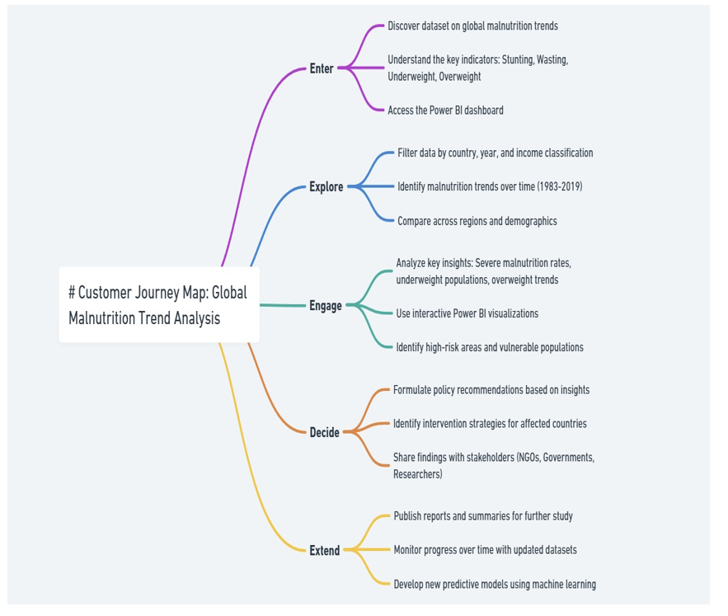

**3.2 Solution Requirement**

|  |  |  |  |  |  |
| --- | --- | --- | --- | --- | --- |
| **FR No.** | **Functional Requirement (Epic)** | **Sub Requirement (Story / Sub-Task)** |  |  |  |
| FR-1 | Data Collection | Fetch data from global health databases (WHO, UNICEF, FAO) |  |  |  |
|  |  | Allow user-uploaded datasets (CSV, Excel) |  |  |  |
| FR-2 | Data Pre-processing | Handling missing values  Standardizing data formats  Data transformation (Normalization, Aggregation) |  |  |  |
| FR-3 | Data Storage | Storing raw and processed data in a database  Ensuring efficient indexing for retrieval |  |  |  |
| FR-4 | Data Analysis | Generating statistical insights  Performing trend analysis |  |  |  |
| FR-5 | Power BI Dashboard | Creating interactive visualizations  User-defined filters and drill-down options  Exporting reports in various formats |  |  |  |
| FR-6 | User Access & Authentication | Login through Email & Password  Social media authentication (Google, LinkedIn) |  |  |  |
| FR-7 | System Notifications | Email notifications for updates  Alerts for data inconsistencies |  |  |  |
| FR-8 | Report Generation | Generating country-wise malnutrition reports  Comparative analysis over different years |  |  |  |
| FR-9 | User Feedback Collection | Collecting user suggestions  Storing and analysing feedback |  |  |  |

**3.3) data flow diagram**

To create a Data Flow Diagram (DFD) for your project on Global Malnutrition Trends Analysis (1983-2019) in Power BI, we need to define how data flows through your system**.**

Example: Data Sources (Entities):

WHO/UNICEF, Government Portals, and NGOs provide raw data.

Data Storage & Processing:

* Raw data is stored, cleaned, and preprocessed.

Data Analysis:

* Processed data undergoes statistical analysis to find trends.

Visualization & Reporting:

* Power BI is used to generate insights.

Final Reports & Decision Making:

* Reports are generated for policymakers & analysts.

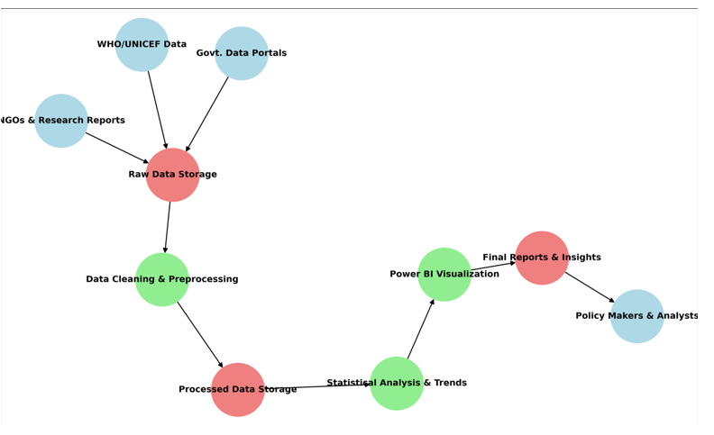

**3.4 technology stack**

This technology stack ensures efficient data handling, insightful analysis, and meaningful visualizations of malnutrition trends. The combination of Python, SQL, data visualization tools, and cloud platforms enables a powerful and scalable approach to extracting insights from global malnutrition data.

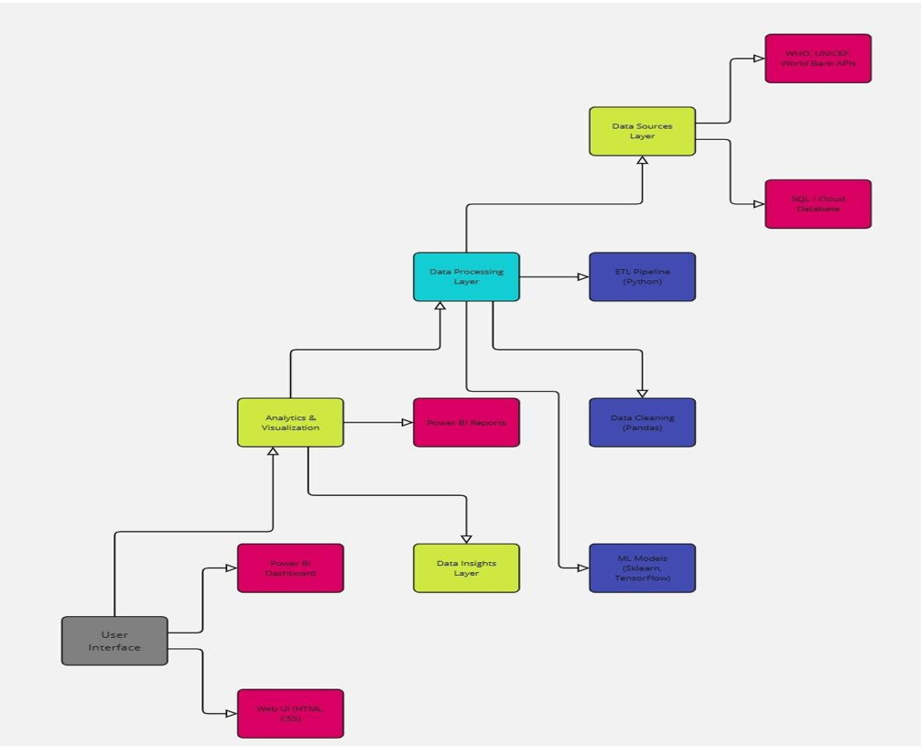

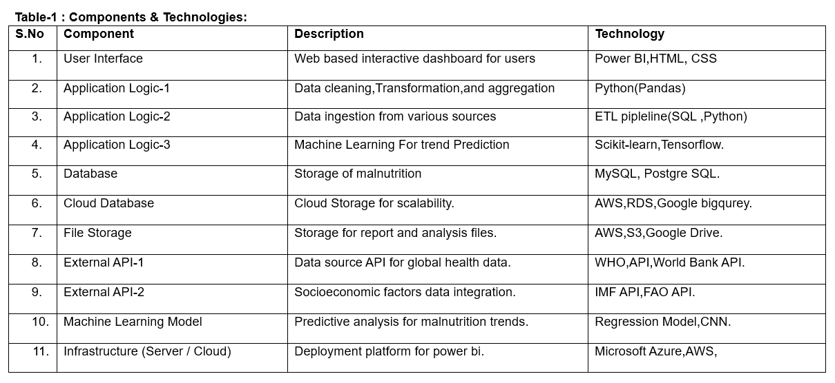

**4.Project Design**

**4.1) problem solution fit**

Problem-Malnutrition has been a persistent global issue, affecting millions of people across different regions and demographics. Understanding long-term trends in malnutrition is crucial for policymakers, healthcare professionals, and organizations working to combat hunger and undernutrition. However, the lack of comprehensive data analysis over time makes it difficult to identify patterns and implement effective interventions.

Solution -Our project analyzes malnutrition trends from 1983 to 2019 using historical data, statistical modeling, and data visualization techniques. By identifying key patterns, regional disparities, and contributing factors, our research provides insights that can help governments and organizations make informed decisions to tackle malnutrition effectively.

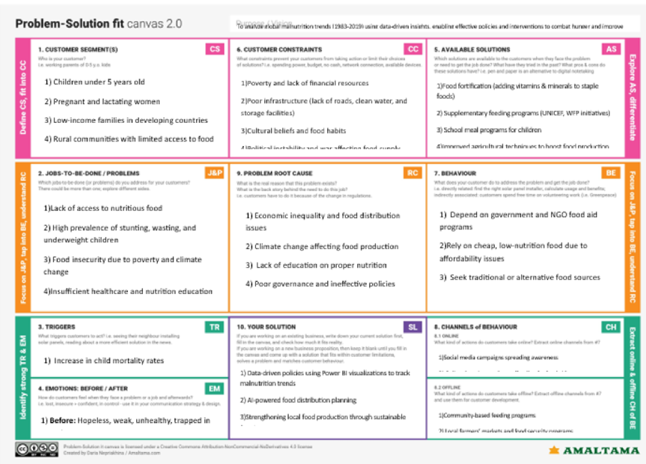

**4.2) proposed solution**

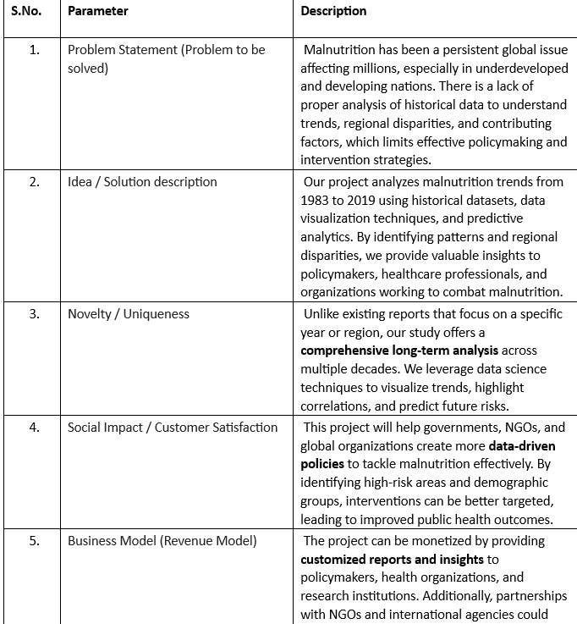

**4.3) Solution Architecture**

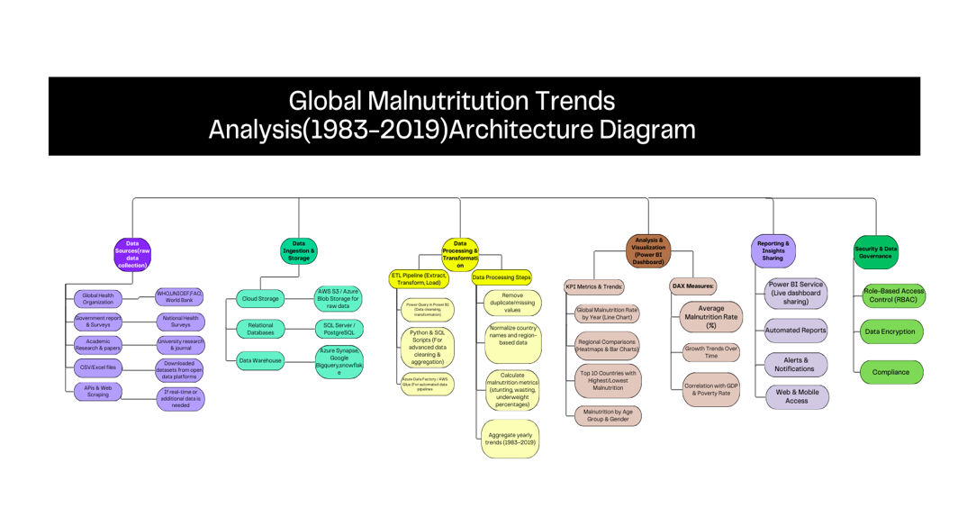

1. **Project planning and scheduling**

Project Planning

The project will be divided into phases:

* Phase 1: Data Collection (1 month)
* Phase 2: Data Preprocessing & Cleaning (1 month)
* Phase 3: Power BI Visualization Development (2 months)
* Phase 4: Testing & Refinement (1 month)

Phase 5: Final Reporting & Presentation (1 month)

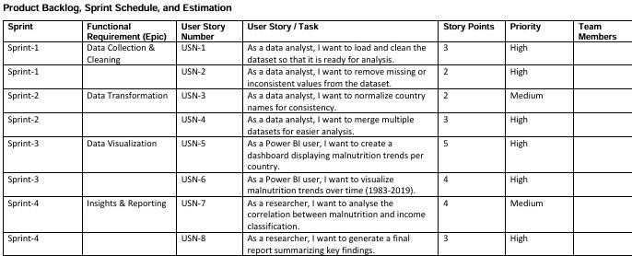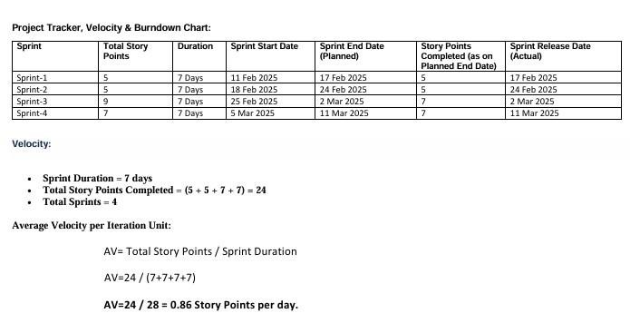

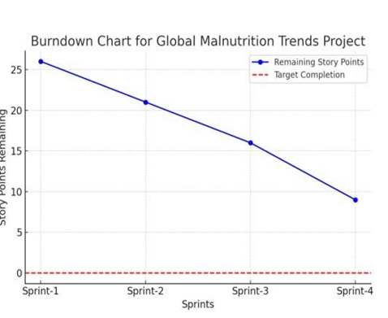

**6.Functional and performance testing**

**Project team shall fill the following information in model performance testing template.**

|  |  |  |
| --- | --- | --- |
| S.No. | Parameter | Screenshot / Values |
|  | Data Rendered |  |
|  | Data Preprocessing |  |
| 3. | Utilization of Data Filters |  |
| 4. | DAX Queries Used | Total Underweight = SUM(Malnutrition[Underweight])  Average Stunting = AVERAGE(Malnutrition[Stunting])  Overweight Percentage = DIVIDE(SUM(Malnutrition[Overweight]), SUM(Malnutrition[Total Population])) * 100 |
| 5. | Dashboard design | No of Visualizations / Graphs – |
| 6 | Report Design | No of Visualizations / Graphs – |

**7.Results**

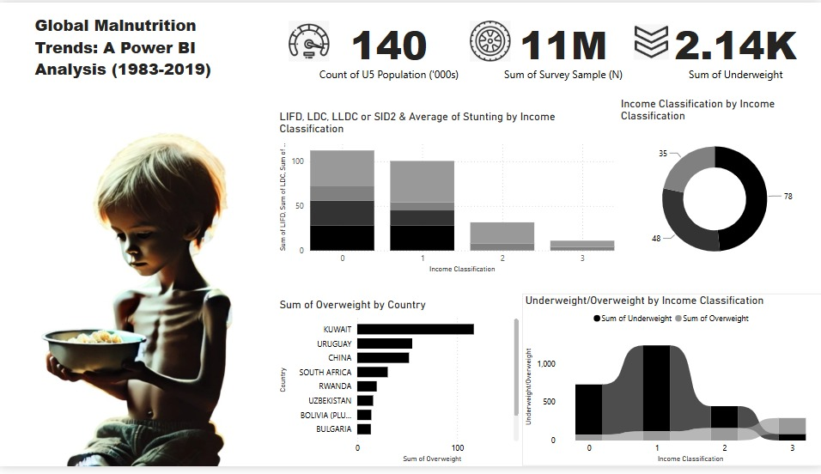

**Report:**

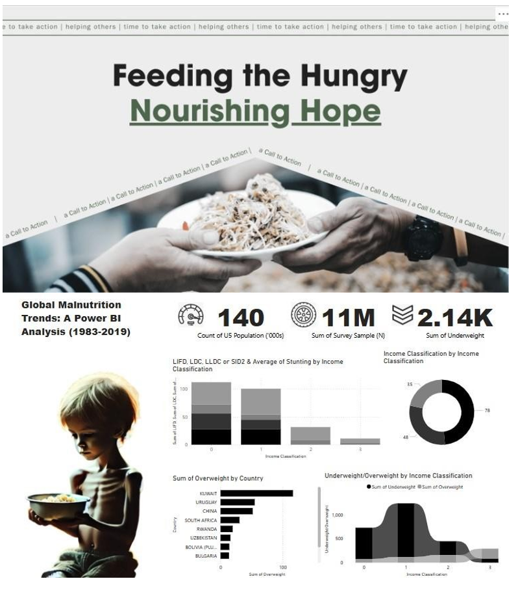

**8. Advantages**

Advantages:

* Easy-to-understand Visuals: Power BI’s interactive visuals help stakeholders make informed decisions quickly.
* Comprehensive Data: It offers a 36-year perspective on global malnutrition trends.
* Customizable: Users can filter data based on region, income group, or type of malnutrition.

Disadvantages*:*

* Data Availability: Inconsistent data reporting in some regions may limit the comprehensiveness of the analysis.
* Learning Curve: Users unfamiliar with Power BI may face a learning curve.
* Real-time Updates: Data may not be updated in real-time unless regularly refreshed from reliable sources.

**9. Conclusion**

Conclusion

The Global Malnutrition Trends Analysis (1983-2019) project provides valuable insights into malnutrition patterns over the years, helping policymakers, researchers, and organizations make data-driven decisions. By leveraging data science, statistical analysis, and visualization techniques, this project identifies key trends, geographical disparities, and contributing factors to malnutrition worldwide.

Through comprehensive data collection, cleaning, and analysis, we have uncovered significant trends in undernutrition, stunting, wasting, and micronutrient deficiencies across different regions. The interactive visualizations and reports make it easier to interpret complex data, allowing stakeholders to focus on effective interventions and policies.

This project serves as a foundation for further research and real-world applications, such as predictive modeling, AI-driven recommendations, and policy impact analysis. Future enhancements could involve real-time data integration, deep learning models for forecasting, and advanced geospatial analytics to refine insights further.

Ultimately, this study contributes to the global fight against malnutrition by providing a data-driven approach to understanding and addressing one of the world's most pressing health challenges.

**Future Scope**

The **Global Malnutrition Trends Analysis (1983-2019)** project has the potential for significant future developments and enhancements. The following areas highlight its future scope:

1. **Real-Time Data Integration**
   * Incorporating real-time data sources such as **WHO, UNICEF, and FAO** reports to provide **up-to-date insights** on malnutrition trends.
   * Using **web scraping and APIs** to fetch live data for continuous monitoring.
2. **Predictive Analytics & AI Models**
   * Developing **machine learning models** to predict future malnutrition trends based on historical data.
   * Implementing **deep learning techniques** for image-based malnutrition detection (e.g., using facial features to assess undernutrition).
3. **Geospatial Analysis & Visualization**
   * Enhancing **geospatial mapping** to analyze malnutrition hotspots more precisely.
   * Using **GIS (Geographic Information Systems)** for policy planning and targeted intervention programs.
4. **Personalized Nutritional Recommendations**
   * Developing a **nutrition recommendation system** based on regional deficiencies.
   * Integrating AI-powered **dietary solutions** for affected populations.
5. **Policy Impact Assessment**
   * Assessing the **effectiveness of government policies** in reducing malnutrition over time.
   * Providing **data-driven recommendations** for future policymaking.

**11. Appendix**

The appendix includes:

Data sources and links.

Reference : <https://www.mural.co/templates/brainstorm-and-idea-prioritization>

Reference : <https://www.mural.co/templates/brainstorm-and-idea-prioritization>

Reference: <https://www.mural.co/templates/empathy-map-canvas>

Reference: https://www.canva.com/?msockid=2747933590ad63ac01df87cb91786285 Global Malnutrition Trends: A Power BI Analysis (1983-2019)

[https://www.kaggle.com/datasets/ruchi798/malnutrition-across-the-globe?select=malnutrition- estimates.csv](https://www.kaggle.com/datasets/ruchi798/malnutrition-across-the-globe?select=malnutrition-%20%20%20%20%20%20%20%20%20estimates.csv)

Global Nutrition Report (2023) –<https://globalnutritionreport.org/>

UNICEF: The State of the World’s Children – Malnutrition Analysis –<https://www.unicef.org/reports>World Bank: Malnutrition and Economic Growth Report –<https://documents.worldbank.org/>

**11.1Git hub link**

<https://github.com/vigh2530/Global-Malnutrition-Trends-A-Power-BI-Analysis-1983-2019-.git>

**11.2 Vedio presentation link**

<https://drive.google.com/file/d/1rJ5SGJHOXVuKvjSDjKXB4ANrpWSN2dKs/view?usp=sharing>